The documentation was written by Olivier Lüthy (creator of the Constant-Framework)
Kauz informatik | medien ag Luzernstrasse 18
CONSTANT-FRAMEWORK

Table of contents
1. Introduction 2
2. Folder structure 2
3. Important files 2
index.php 2
viewData.view.php 5

- Introduction
When you have read the “README.md” File from the repository, you know the reason why I build the framework on the first place.
- Folder structure
At the following you can find the folder structure of that project.
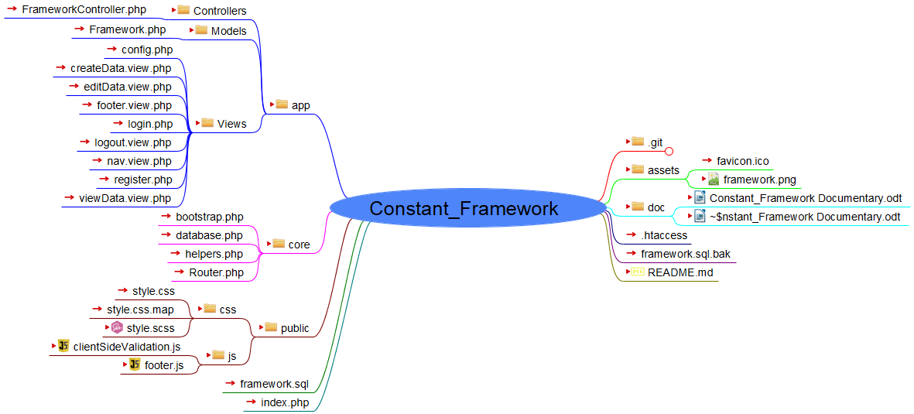
You don’t have to understand everything. I will only show and explain the important files.
- Important files

index.php
In this file you can define all your routes. You will get to the home page when you enter http://localhost/Constant_Framework/ or http://localhost/Constant_Framework/view. Both will direct you to the index page. But how will it get to that?

Everything will do the FrameworkController.php File. When I enter one of this URLs, it will go to the defined controller and then search for the index function. Here we see that the index function is right on the top of the file. This page will run everything that is inside of this function. Now what the page will do is, that it creates an object of the Framework class where you can find in the Framework.php File. In there is the class Framework defined. After that the function will connect with the database. This function is declared in the database.php File. After that the created object will run the function index, where the select statement will happen. The output of the select statement will be stored in the $daten variable. On the last part the $daten variable will be opened within the fetchAll() function and will be declared back to the $daten variable. The last step is, that the function opens the viewData.view.php page where the data will be shown. I don’t explain more because each function does pretty much the same.

viewData.view.php
Within the foreach statement the object will be displayed on the website.

